**Phase 2: Org Setup & Configuration**

**Overview**

In Phase 2, the focus is on setting up the Salesforce organizational environment.

**1: Create Developer Org**

* Registered a Salesforce Developer Edition Org dedicated to this Supply Chain & Inventory Management project.
* Confirmed org activation and granted Admin access.

**2: Company Profile Setup**

* Navigated to Setup → Company Information.
* Set:
  + Company Name: *Supply Chain Solutions Inc.*
  + Primary Contact: *Adarsh Sondhiya*
  + Default Currency: *INR*
  + Default Language: *English*
  + Address and Time zone: Set to organization location and local time zone.
* Documented company details for future reference.

**3: Business Hours & Holidays Setup**

* Setup → Business Hours.
* Created standard operating hours:
  + Name: *Standard Operations*
  + Time zone: *(GMT+05:30) India Standard Time (Asia/Kolkata)*
  + Working days: *Monday – Friday, 10 AM to 6 PM*
  + Weekends off
* Added holidays as non-working days (e.g., New Year's Day, Independence Day, Christmas).

**4: Fiscal Year Setup**

* Setup → Fiscal Year
* Configured Standard Fiscal Year(Jan-Dec)

**5: User Setup & Licenses**

* Created users for project roles:
  + **System Administrator:**
  + **Warehouse Manager:**
  + **Procurement Specialist:**
  + **Inventory Clerk:**
  + **Executive Viewer:**

**6: Role Hierarchy Setup**

* Setup → Roles.
* Defined organizational roles to model data visibility hierarchy:

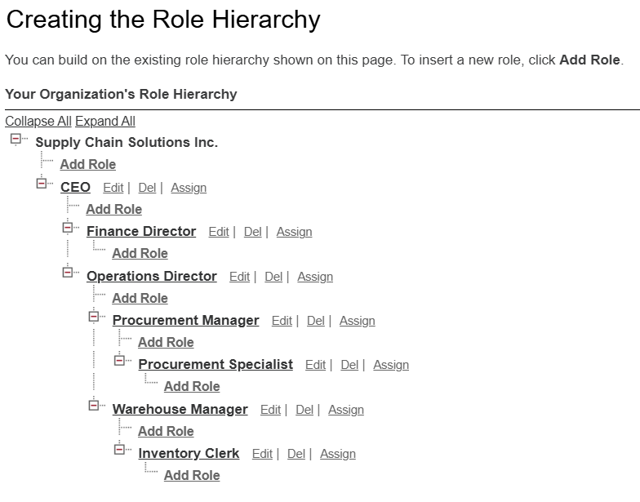

* Created role hierarchy reflecting business structure for sharing purposes.

**7: Profiles & Permission Sets**

* Cloned standard Salesforce profiles and tailored as per roles.
* Created custom permission sets for specific privileges like:
  + Purchase order approval permissions
  + Supplier record access
  + Inventory management permissions
* Assigned profiles and permission sets to users accordingly.

**8: Organization-Wide Defaults (OWD)**

* **Note:** Actual OWD settings configured after Phase 3 object creation.
* Prepared to set defaults like:
  + Warehouse: Public Read/Write
  + Product: Public Read Only
  + Supplier: Private
  + Purchase Order: Public Read Only
  + Inventory: Private

**9: Sharing Rules**

* Planned sharing rules to grant additional access as per roles.
  + Share Suppliers with Procurement Team role.
  + Share Purchase Orders with Finance Team public roles.

**10: Development Environment & Tools Setup**

* Enabled **Dev Hub** in setup for Salesforce Developer Org management.
* Prepared connection to development tools (Visual Studio Code with Salesforce Extensions).

**Summary**

Phase 2 established a robust Salesforce environment for subsequent project development.